**NLP Project Report**

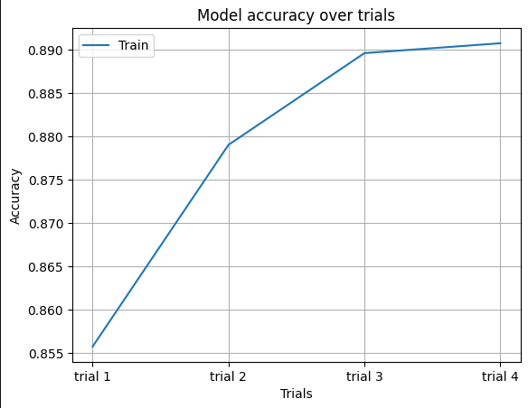*CNN Model:*

* By increasing the number of neurons, accuracy of the model increases also.
* Best parameter when I chose neurons equal to 1024.
* Accuracies:
* Trial 1: 0.8558 (85.58%), used no. of neurons = 128
* Trial 2: 0.8790 (87.90%), used no. of neurons = 256
* Trial 3: 0.8896 (88.96%), used no. of neurons = 512
* Trial 4: 0.8908 (89.08%), used no. of neurons = 1024

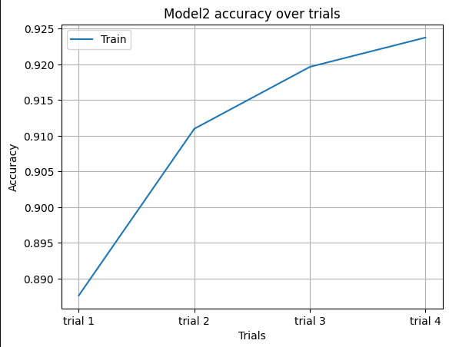LSTM Model:

* By increasing the number of neurons, accuracy of the model increases also.
* Best parameter when I chose neurons equal to 1024.
* Accuracies:
* Trial 1: 0.8876 (88.76%), used no. of neurons = 128
* Trial 2: 0.9110 (91.10%), used no. of neurons = 256
* Trial 3: 0.9196 (91.96%), used no. of neurons = 512
* Trial 4: 0.9238 (92.38%) , used no. of neurons = 1024

*Screenshot of users input of new tweets:*

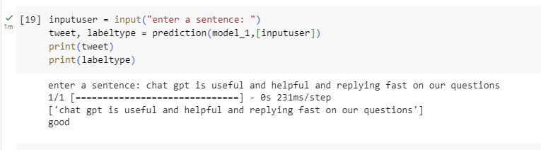For CNN Model:

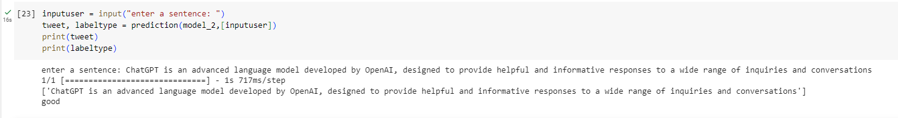For LSTM Model:

*Screenshot of the python code <<best accuracy results>> for each model:*

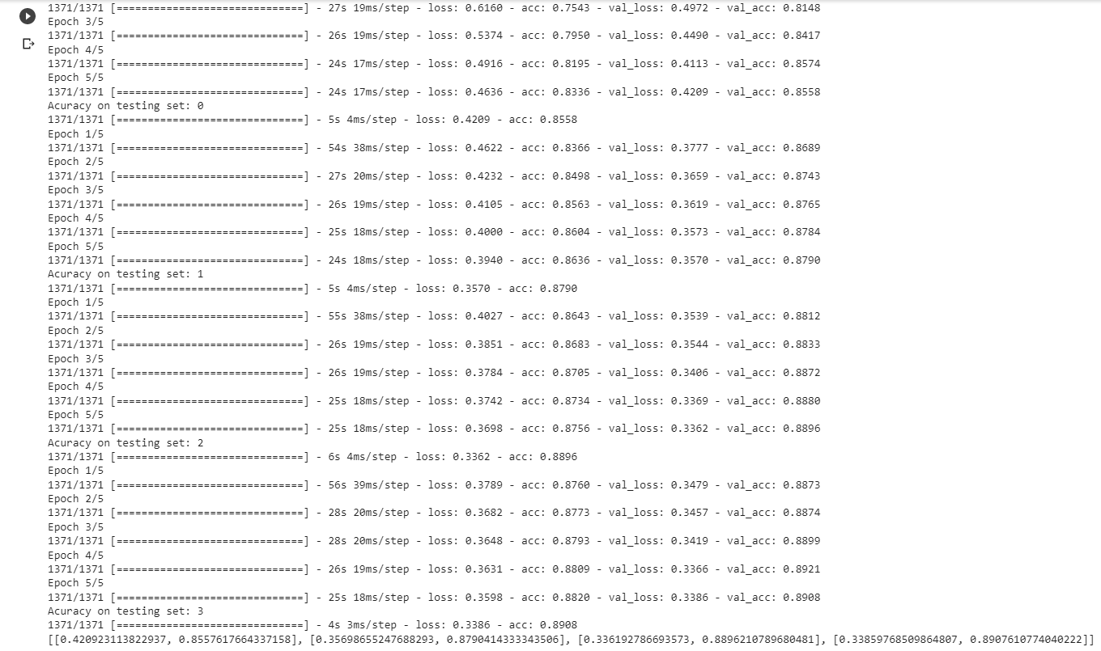CNN Model:

* Best accuracy is the highlighted one.
* 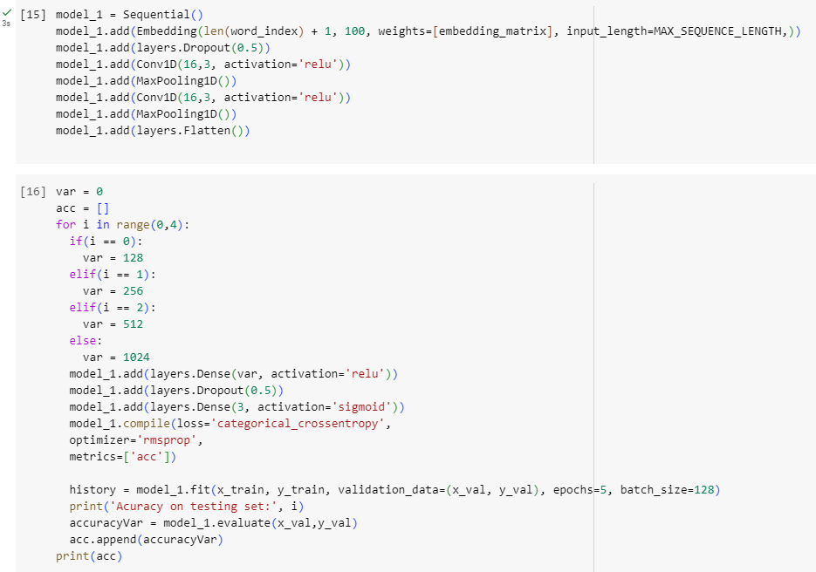In the highlighted function, when the variable “ var” equal to 1024.

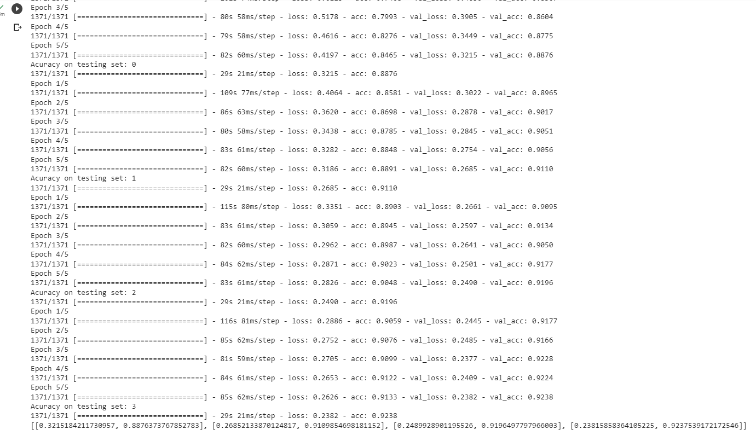LSTM Model:

* Best accuracy is the highlighted one.

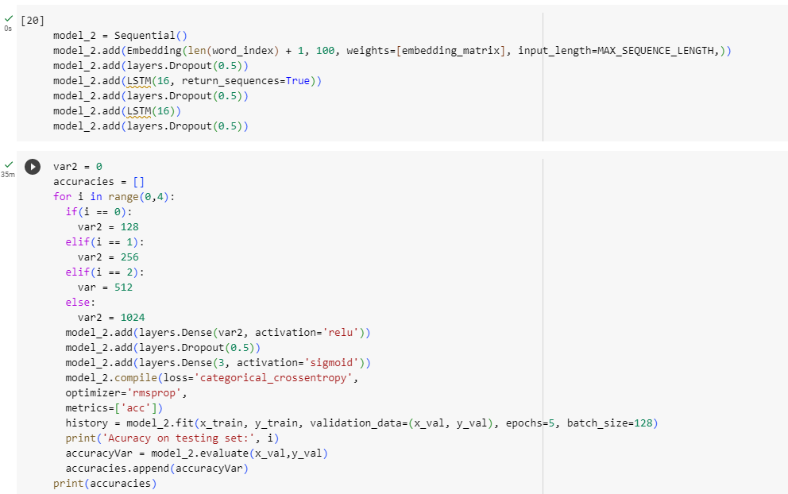

* In the highlighted function, when the variable “ var2” equal to 1024.